Jesuit High School
Hybrid eLearning Class Meetings

Setting up Zoom Instructions

Important: Before scheduling any Zoom sessions, please make sure your Zoom app is up-to-date on both your PC and your iPad.

On a Mac, launch the Zoom app, then click Zoom.us on the upper left hand side. Click “Check for Updates”.

On your iPad, go to the App Store, click the profile picture on the upper right hand corner, swipe down to refresh the app list, then click Update on Zoom.

On a PC, log in to the Zoom app. Click on your account initials, then click “Check for Updates”.

Creating Live Meetings with Zoom/Posting to Canvas
(Follow Step 1 if you’ve never downloaded Zoom software)

- Downloading Zoom
  - Using a web browser, go to Zoom.us
  - Sign in using your Jesuit email.
  - If you don’t have an account, enter your Jesuit email address and click Sign Up. You will be emailed a link to create your Zoom account.
  - Hover over Resources then click Download Zoom Client.
  - Install Zoom

- Log in to Zoom and set up your Personal Meeting Room
  - For Hybrid eLearning, we will be using your Personal Meeting Room, rather than going to the exhaustive process of scheduling meetings around your class times.
  - Log into the Zoom app and click the down arrow below New Meeting. Check the box for “Use my Personal Meeting ID”
  - Hover over your Meeting ID number and choose PMI Settings.
  - Turn off Video for participants.

- Starting a Personal Meeting.
  - When you use a Personal Meeting, the link never changes. This is the link you will post at the top of your Canvas course. Whenever a student is absent, getting your Zoom going is as simple as launching the app and clicking New Meeting. From the Waiting Room, only admit students from the Waiting Room that are absent from that specific section.
  - Click on the Participants button, then click More in the lower right corner.
  - Check Mute Participants on Entry. Do not give the students permission to unmute themselves. Do not allow students to rename themselves.

- Add your Personal Meeting ID link and Password to Canvas
  - Because we’re taking advantage of the waiting room, your Link and Password never change or expire. Students will only be able to join your Zoom if you’re live.
  - Click the Copy Link button in Zoom.
  - Go back to Canvas and create a new Module. Call the module “ZOOM LINK FOR ELEARNING” or something similar. Put the Zoom password here as well.
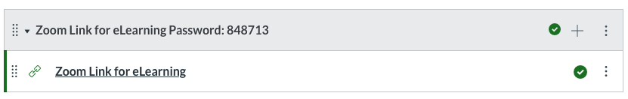
  - Add content to the module and choose External URL. Paste the URL and give the page the name Zoom Link for eLearning.
  - Students absent will be able to click the link and go to the Waiting Room.

